**Experiment 1**

**TITLE:** **DDL (Data Definition Language) commands**

**Objective:** To understand the concept of designing issue related to the database with creating, populating the tables.

1. **Create the tables described below:**

**Table name: CLIENT_MASTER**

**Description:** Used to store client information.

|  |  |  |
| --- | --- | --- |
| **Column Name** | **Data Type** | **Size** |
| CLIENTNO | Varchar | 6 |
| NAME | Varchar | 20 |
| ADDRESS 1 | Varchar | 30 |
| ADDRESS 2 | Varchar | 30 |
| CITY | Varchar | 15 |
| PINCODE | Integer |  |
| STATE | Varchar | 15 |
| BALDUE | decimal | 10,2 |

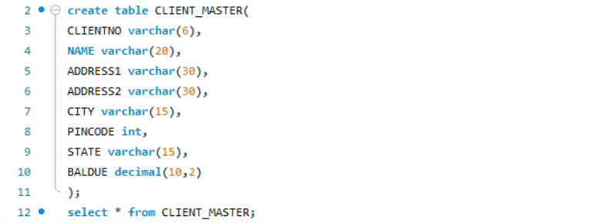

**CMT2**

**Table Name: PRODUCT_MASTER Description:** Used to store product information

|  |  |  |
| --- | --- | --- |
| **Column Name** | **Data Type** | **Size** |
| PRODUCTNO | Varchar | 6 |
| DESCRIPTION | Varchar | 15 |
| PROFITPERCENT | Decimal | 4,2 |
| UNIT MEASURE | Varchar | 10 |
| QTYONHAND | Integer |  |
| REORDERL VL | Integer |  |
| SELLPRICE | Decimal | 8,2 |
| COSTPRICE | Decimal | 8,2 |

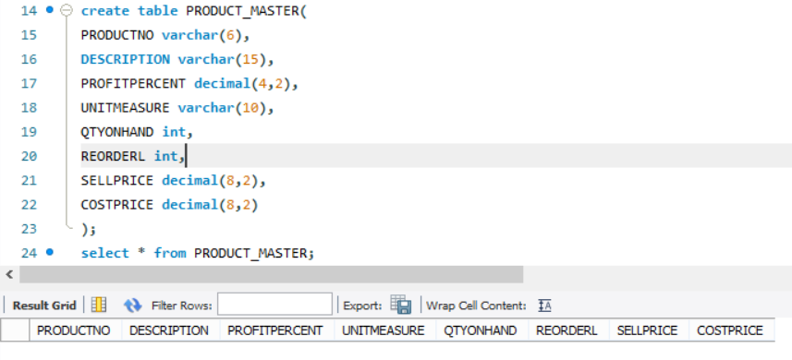

**Table Name: SALESMAN_MASTER**

**Description:** Used to store salesman information working for the company.

|  |  |  |
| --- | --- | --- |
| **Column Name** | **Data Type** | **Size** |
| SALESMANNO | Varchar | 6 |
| SALESMANNAME | Varchar | 20 |
| ADDRESS 1 | Varchar | 30 |
| ADDRESS 2 | Varchar | 30 |
| CITY | Varchar | 20 |
| PINCODE | Integer |  |
| STATE | Varchar | 20 |
| SALAMT | Real |  |
| TGTTOGET | Decimal |  |
| YTDSALES | Double | 6,2 |
| REMARKS | Varchar | 60 |

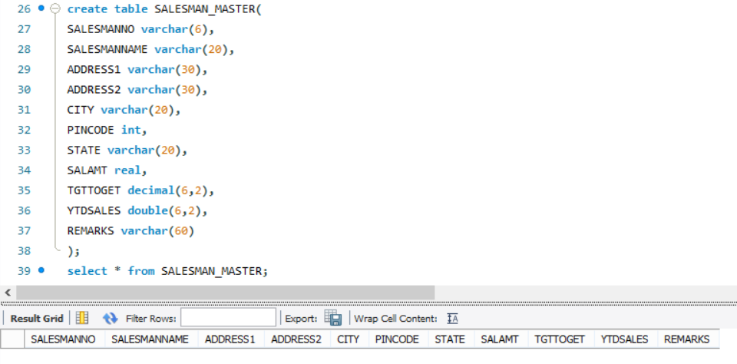

1. **Insert the following data into their respective tables:**
2. Data for **CLIENT_MASTER** table:

|  |  |  |  |  |  |
| --- | --- | --- | --- | --- | --- |
| **CLIENTNO** | **NAME** | **CITY** | **PINCODE** | **STATE** | **BALDUE** |
| C00001 | Ivan bayross | Mumbai | 400054 | Maharashtra | 15000 |
| C00002 | Mamta muzumdar | Madras | 780001 | Tamil nadu | 0 |
| C00003 | Chhaya bankar | Mumbai | 400057 | Maharashtra | 5000 |
| C00004 | Ashwini joshi | Bangalore | 560001 | Karnataka | 0 |
| C00005 | Hansel colaco | Mumbai | 400060 | Maharashtra | 2000 |
| C00006 | Deepak sharma | Mangalore | 560050 | Karnataka | 0 |

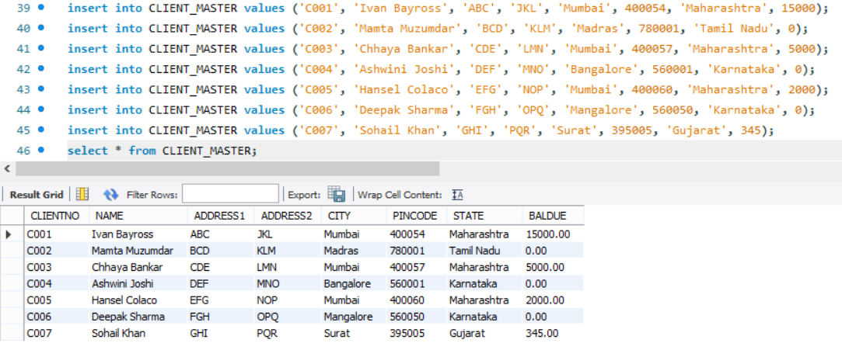

1. Data for **PRODUCT**_**MASTER** table:

|  |  |  |  |  |  |  |  |
| --- | --- | --- | --- | --- | --- | --- | --- |
| **PRODUCTNO** | **DESCRIPTION** | **PROFIT**  **PERCENT** | **UNIT**  **MEASURE** | **QTYONHAND** | **REORDERL** | **SELL**  **PRICE** | **COST**  **PRICE** |
| P00001 | T-Shirt | 5 | Piece | 200 | 50 | 350 | 250 |
| P0345 | Shirts | 6 | Piece | 150 | 50 | 500 | 350 |
| P06734 | Cotton jeans | 5 | Piece | 100 | 20 | 600 | 450 |
| P07865 | Jeans | 5 | Piece | 100 | 20 | 750 | 500 |
| P07868 | Trousers | 2 | Piece | 150 | 50 | 850 | 550 |
| P07885 | Pull Overs | 2.5 | Piece | 80 | 30 | 700 | 450 |
| P07965 | Denim jeans | 4 | Piece | 100 | 40 | 350 | 250 |
| P07975 | Lycra tops | 5 | Piece | 70 | 30 | 300 | 175 |
| P08865 | Skirts | 5 | Piece | 75 | 30 | 450 | 300 |

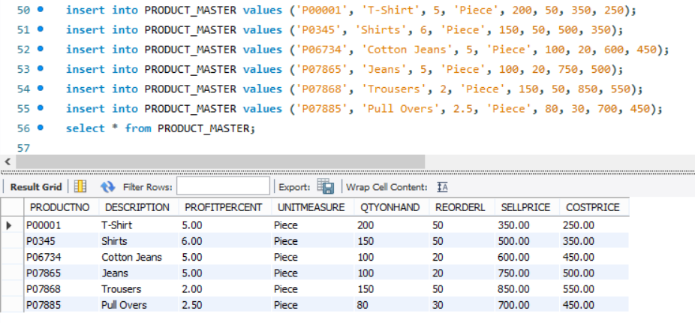

1. Data for **SALESMAN_MASTER**  table:

|  |  |  |  |  |  |  |
| --- | --- | --- | --- | --- | --- | --- |
| **SALESMANNO** | **NAME** | **ADDRESS1** | **ADDRESS2** | **CITY** | **PINCODE** | **STATE** |
| S00001 | Aman | A/14 | Worli | Mumbai | 400002 | Maharashtra |
| S00002 | Omkar | 65 | Nariman | Mumbai | 400001 | Maharashtra |
| S00003 | Raj | P-7 | Bandra | Mumbai | 400032 | Maharashtra |
| S00004 | Ashish | A/5 | Juhu | Mumbai | 400044 | Maharashtra |

|  |  |  |  |  |  |  |
| --- | --- | --- | --- | --- | --- | --- |
| **SALESMANNO** | **SALAMT** | **TTGTOGET** | | **YTDSALES** | | **REMARKS** |
| S00001 | 3000 | 100 | 50 | | Good | |
| S00002 | 3000 | 200 | 100 | | Good | |
| S00003 | 3000 | 200 | 100 | | Good | |
| S00004 | 3500 | 200 | 150 | | Good | |

